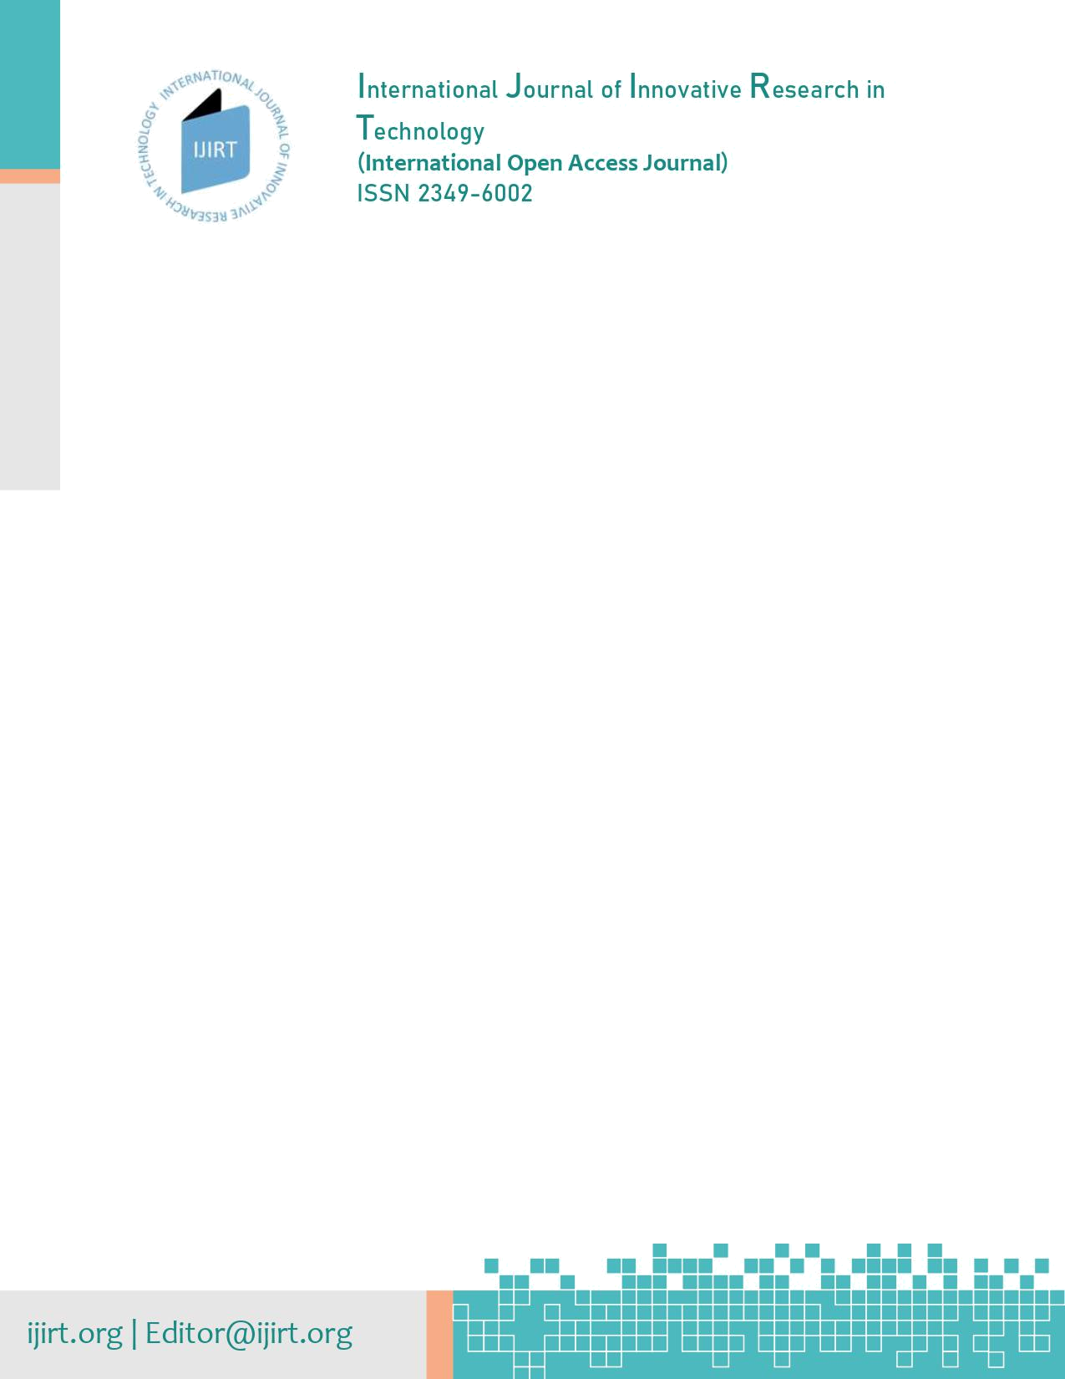

UNDER TAKING BY AUTHORS

I/We, the undersigned, give an undertaking to the following effect with regard to following mentioned article that submitted for publication in the International Journal of Innovative Research in Technology (IJIRT)

Paper ID : 155039

Article Title : Augmentation Techniques Analysis with removal of Class Imbalance using PyTorch for Intel Scene Dataset

We warrant that,

a. The manuscript submitted is my/our own original work;

b. All authors participated in the work in a substantive way and are prepared to take public responsibility for the work;

c. I/we was authorized by all authors to transfer all royalties related with the manuscript and to enter into a binding contract with IJIRT as detailed in this Copyright Release Form, and I/we will be responsible in the event of all disputes that have occurred and that may occur,

d. All authors have seen and approved the manuscript as submitted;

e. The manuscript has not been published and is not being submitted or considered for publication elsewhere;

f. The text, illustrations, and any other materials included in the manuscript do not infringe upon any existing copyright or other rights of anyone.

g. I/we transfer all financial rights, especially processing, reproduction, representation, printing, distribution, and online transmittal, to IJIRT with no limitation whatsoever,

h. If IJIRT found any copyright content or any issue related to copyright in future than IJIRT have rights to withdraw the paper without prior notice to authors.

Notwithstanding the above, the Contributor(s) or, if applicable the Employer of Contributor, retain(s) all proprietary rights other than copyright, such as

a. Patent rights;

b. To use, free of charge, all parts of this article for the authors future works in books, lectures, classroom teaching, oral presentations;

c. The right to reproduce the article for their own purposes provided the copies are not offered for sale

NOTE: if all auhtor are not available than sign this form with only 1(Single) author. 1(Single) author sign is enough for this form, Sign and send scanned copy to editor@IJIRT.org

Sr.# | Author | Signature
1 | Anusha Kanukolanu | 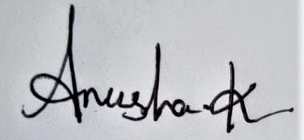
2 | Dr. S Phani Kumar
3 | Allena Venkata Sai Abhishek

DATE : 2 1 | 0 5 |2 0 2 2 (DD|MM|YYYY) Place : Hyderabad

Powered by TCPDF (www.tcpdf.org)

